1. In an arithmetic sequence, u1 = 2 and u3 = 8.
(a) Find d.
(2)
(b) Find u20.
(2)
(c) Find S20.
(2)
(Total 6 marks)

2. In an arithmetic sequence u1 = 7, u20 = 64 and un = 3709.
(a) Find the value of the common difference.
(3)

(b) Find the value of n.
(2)
(Total 5 marks)

3. Consider the arithmetic sequence 3, 9, 15, ..., 1353.
(a) Write down the common difference.
(1)

(b) Find the number of terms in the sequence.
(3)

(c) Find the sum of the sequence.
(2)
(Total 6 marks)

4. An arithmetic sequence, u1, u2, u3, ..., has d = 11 and u27 = 263.
(a) Find u1.
(2)

(b) (i) Given that un = 516, find the value of n.
(ii) For this value of n, find Sn.
(4)
(Total 6 marks)

5. The first three terms of an infinite geometric sequence are 32, 16 and 8.
(a) Write down the value of r.
(1)

(b) Find u6.
(2)

(c) Find the sum to infinity of this sequence.
(2)
(Total 5 marks)

6. The nth term of an arithmetic sequence is given by un = 5 + 2n.
(a) Write down the common difference.
(1)

(b) (i) Given that the nth term of this sequence is 115, find the value of n.
(ii) For this value of n, find the sum of the sequence.
(5)
(Total 6 marks)

7. In an arithmetic series, the first term is –7 and the sum of the first 20 terms is 620.
(a) Find the common difference.
(3)

(b) Find the value of the 78th term.
(2)
(Total 5 marks)

8. In a geometric series, u1 = 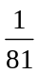 and u4 = .
(a) Find the value of r.
(3)

(b) Find the smallest value of n for which Sn > 40.
(4)
(Total 7 marks)

9. (a) Expand 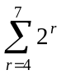 as the sum of four terms.
(1)

(b) (i) Find the value of 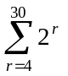.
(ii) Explain why 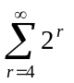 cannot be evaluated.
(6)
(Total 7 marks)

10. In an arithmetic sequence, S40 = 1900 and u40 = 106. Find the value of u1 and of d.
(Total 6 marks)

11. Consider the arithmetic sequence 2, 5, 8, 11, ....
(a) Find u101.
(3)
(b) Find the value of n so that un = 152.
(3)
(Total 6 marks)

12. Consider the infinite geometric sequence 3000, – 1800, 1080, – 648, … .
(a) Find the common ratio.
(2)
(b) Find the 10th term.
(2)
(c) Find the exact sum of the infinite sequence.
(2)
(Total 6 marks)

13. Consider the infinite geometric sequence 3, 3(0.9), 3(0.9)2, 3(0.9)3, … .
(a) Write down the 10th term of the sequence. Do not simplify your answer.
(1)

(b) Find the sum of the infinite sequence.
(4)
(Total 5 marks)

14. In an arithmetic sequence u21 = –37 and u4 = –3.
(a) Find
(i) the common difference;
(ii) the first term.
(4)

(b) Find S10.
(3)
(Total 7 marks)

15. Let un = 3 – 2n.
(a) Write down the value of u1, u2, and u3.
(3)

(b) Find 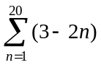.
(3)
(Total 6 marks)

16. A theatre has 20 rows of seats. There are 15 seats in the first row, 17 seats in the second row, and each successive row of seats has two more seats in it than the previous row.
(a) Calculate the number of seats in the 20th row.
(4)

(b) Calculate the total number of seats.
(2)
(Total 6 marks)

17. A sum of $ 5000 is invested at a compound interest rate of 6.3 % per annum.
(a) Write down an expression for the value of the investment after n full years.
(1)

(b) What will be the value of the investment at the end of five years?
(1)

(c) The value of the investment will exceed $ 10 000 after n full years.
(i) Write down an inequality to represent this information.
(ii) Calculate the minimum value of n.
(4)
(Total 6 marks)

18. Consider the infinite geometric sequence 25, 5, 1, 0.2, … .
(a) Find the common ratio.
(b) Find
(i) the 10th term;
(ii) an expression for the nth term.
(c) Find the sum of the infinite sequence.
(Total 6 marks)

19. The first four terms of a sequence are 18, 54, 162, 486.
(a) Use all four terms to show that this is a geometric sequence.
(2)

(b) (i) Find an expression for the nth term of this geometric sequence.
(ii) If the nth term of the sequence is 1062 882, find the value of n.
(4)
(Total 6 marks)

20. (a) Write down the first three terms of the sequence un = 3n, for n ≥1.
(1)

(b) Find
(i) 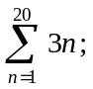
(ii) 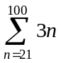.
(5)
(Total 6 marks)

21. Consider the infinite geometric series 405 + 270 + 180 +....
(a) For this series, find the common ratio, giving your answer as a fraction in its simplest form.
(b) Find the fifteenth term of this series.
(c) Find the exact value of the sum of the infinite series.
(Total 6 marks)

22. (a) Consider the geometric sequence −3, 6, −12, 24, ….
(i) Write down the common ratio.
(ii) Find the 15th term.
Consider the sequence x − 3, x +1, 2x + 8, ….
(3)

(b) When x = 5, the sequence is geometric.
(i) Write down the first three terms.
(ii) Find the common ratio.
(2)

(c) Find the other value of x for which the sequence is geometric.
(4)

(d) For this value of x, find
(i) the common ratio;
(ii) the sum of the infinite sequence.
(3)
(Total 12 marks)

23. Let Sn be the sum of the first n terms of the arithmetic series 2 + 4 + 6 + ….
(a) Find
(i) S4;
(ii) S100.
(4)

Let M = 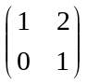.
(b) (i) Find M2.
(ii) Show that M3 = 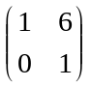.
(5)

It may now be assumed that Mn = 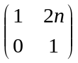, for n ≥ 4. The sum Tn is defined by
Tn = M1 + M2 + M3 + ... + Mn .
(c) (i) Write down M4.
(ii) Find T4.
(4)

(d) Using your results from part (a) (ii), find T100.
(3)
(Total 16 marks)

24. Clara organizes cans in triangular piles, where each row has one less can than the row below. For example, the pile of 15 cans shown has 5 cans in the bottom row and 4 cans in the row above it.
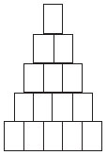
(a) A pile has 20 cans in the bottom row. Show that the pile contains 210 cans.
(4)

(b) There are 3240 cans in a pile. How many cans are in the bottom row?
(4)

(c) (i) There are S cans and they are organized in a triangular pile with n cans in the bottom row. Show that n2 + n − 2S = 0.
(ii) Clara has 2100 cans. Explain why she cannot organize them in a triangular pile.
(6)
(Total 14 marks)

25. A theatre has 20 rows of seats. There are 15 seats in the first row, 17 seats in the second row, and each successive row of seats has two more seats in it than the previous row.
(a) Calculate the number of seats in the 20th row.
(b) Calculate the total number of seats.
(Total 6 marks)

26. A sum of $5000 is invested at a compound interest rate of 6.3% per annum.
(a) Write down an expression for the value of the investment after n full years.
(b) What will be the value of the investment at the end of five years?
(c) The value of the investment will exceed $10000 after n full years,
(i) Write down an inequality to represent this information.
(ii) Calculate the minimum value of n.
(Total 6 marks)

27. Let Sn be the sum of the first n terms of an arithmetic sequence, whose first three terms are u1, u2 and u3. It is known that S1 = 7, and S2 = 18.
(a) Write down u1.
(b) Calculate the common difference of the sequence.
(c) Calculate u4.
Working:
Answers:
(a) ..................................................................
(b) ..................................................................
(c) ..................................................................
(Total 6 marks)

28. The first term of an infinite geometric sequence is 18, while the third term is 8. There are two possible sequences. Find the sum of each sequence.
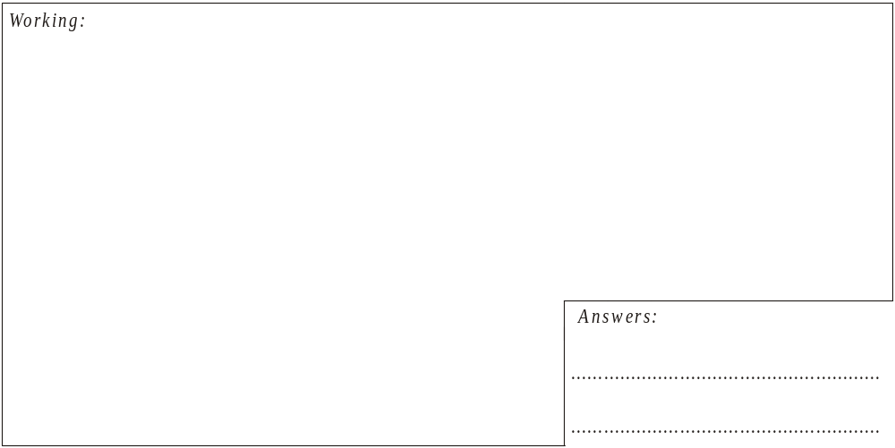
(Total 6 marks)

29. The following table shows four series of numbers. One of these series is geometric, one of the series is arithmetic and the other two are neither geometric nor arithmetic.
(a) Complete the table by stating the type of series that is shown.
Series |  | Type of series
(i) | 111111111111111…
(ii) | 1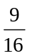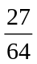…
(iii) | 0.90.8750.850.8250.8…
(iv) | 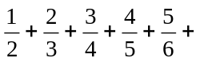…
(b) The geometric series can be summed to infinity. Find this sum.
Working:
Answer:
(b) …………………………………………..
(Total 6 marks)

30. A company offers its employees a choice of two salary schemes A and B over a period of 10 years.
Scheme A offers a starting salary of $11000 in the first year and then an annual increase of $400 per year.
(a) (i) Write down the salary paid in the second year and in the third year.
(ii) Calculate the total (amount of) salary paid over ten years.
(3)

Scheme B offers a starting salary of $10000 dollars in the first year and then an annual increase of 7% of the previous year’s salary.
(b) (i) Write down the salary paid in the second year and in the third year.
(ii) Calculate the salary paid in the tenth year.
(4)

(c) Arturo works for n complete years under scheme A. Bill works for n complete years under scheme B. Find the minimum number of years so that the total earned by Bill exceeds the total earned by Arturo.
(4)
(Total 11 marks)

31. Gwendolyn added the multiples of 3, from 3 to 3750 and found that
3 + 6 + 9 + … + 3750 = s.
Calculate s.
Working:
Answer:
..................................................................
(Total 6 marks)

32. The number of hours of sleep of 21 students are shown in the frequency table below.
Hours of sleep | Number of students
4 | 2
5 | 5
6 | 4
7 | 3
8 | 4
10 | 2
12 | 1
Find
(a) the median;
(b) the lower quartile;
(c) the interquartile range.
Working:
Answers:
(a) ..................................................................
(b) ..................................................................
(c) ..................................................................
(Total 6 marks)

33. Arturo goes swimming every week. He swims 200 metres in the first week. Each week he swims 30 metres more than the previous week. He continues for one year (52 weeks).
(a) How far does Arturo swim in the final week?
(b) How far does he swim altogether?
Working:
Answers:
(a) ..................................................................
(b) ..................................................................
(Total 6 marks)

34. The diagrams below show the first four squares in a sequence of squares which are subdivided in half. The area of the shaded square A is .
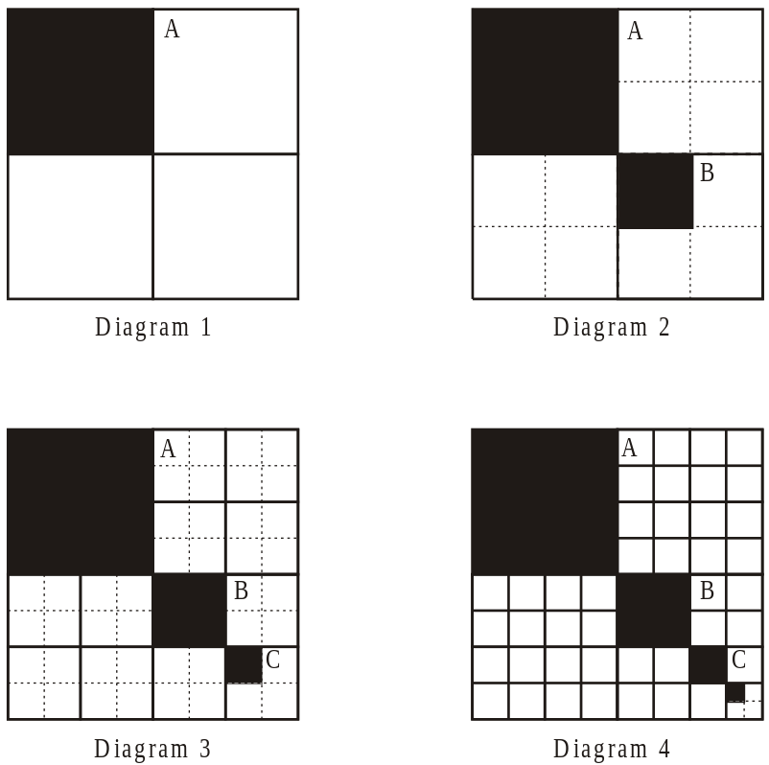
(a) (i) Find the area of square B and of square C.
(ii) Show that the areas of squares A, B and C are in geometric progression.
(iii) Write down the common ratio of the progression.
(5)

(b) (i) Find the total area shaded in diagram 2.
(ii) Find the total area shaded in the 8th diagram of this sequence.
Give your answer correct to six significant figures.
(4)

(c) The dividing and shading process illustrated is continued indefinitely.
Find the total area shaded.
(2)
(Total 11 marks)

35. In an arithmetic sequence, the first term is –2, the fourth term is 16, and the nth term is 11 998.
(a) Find the common difference d.
(b) Find the value of n.
Working:
Answers:
(a) ..................................................................
(b) ..................................................................
(Total 6 marks)

36. Ashley and Billie are swimmers training for a competition.
(a) Ashley trains for 12 hours in the first week. She decides to increase the amount of time she spends training by 2 hours each week. Find the total number of hours she spends training during the first 15 weeks.
(3)

(b) Billie also trains for 12 hours in the first week. She decides to train for 10% longer each week than the previous week.
(i) Show that in the third week she trains for 14.52 hours.
(ii) Find the total number of hours she spends training during the first 15 weeks.
(4)

(c) In which week will the time Billie spends training first exceed 50 hours?
(4)
(Total 11 marks)

37. The diagram shows a square ABCD of side 4 cm. The midpoints P, Q, R, S of the sides are joined to form a second square.
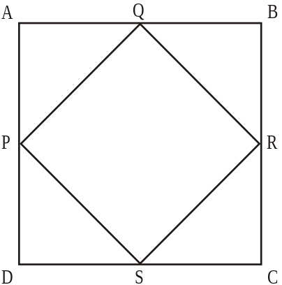
(a) (i) Show that PQ = 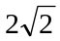 cm.
(ii) Find the area of PQRS.
(3)

The midpoints W, X, Y, Z of the sides of PQRS are now joined to form a third square as shown.
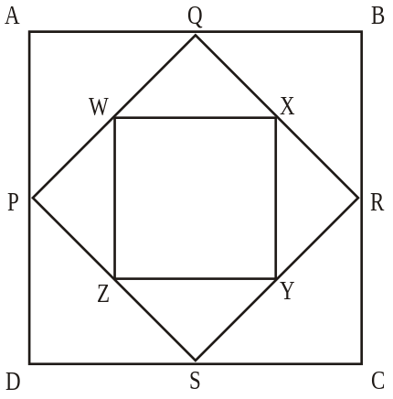

(b) (i) Write down the area of the third square, WXYZ.
(ii) Show that the areas of ABCD, PQRS, and WXYZ form a geometric
sequence. Find the common ratio of this sequence.
(3)

The process of forming smaller and smaller squares (by joining the midpoints) is continued indefinitely.
(c) (i) Find the area of the 11th square.
(ii) Calculate the sum of the areas of all the squares.
(4)
(Total 10 marks)

38. The first three terms of an arithmetic sequence are 7, 9.5, 12.
(a) What is the 41st term of the sequence?
(b) What is the sum of the first 101 terms of the sequence?
Working:
Answers:
(a) ..................................................................
(b) ..................................................................
(Total 4 marks)

39. Portable telephones are first sold in the country Cellmania in 1990. During 1990, the number of units sold is 160. In 1991, the number of units sold is 240 and in 1992, the number of units sold is 360.
In 1993 it was noticed that the annual sales formed a geometric sequence with first term 160, the 2nd and 3rd terms being 240 and 360 respectively.
(a) What is the common ratio of this sequence?
(1)
Assume that this trend in sales continues.
(b) How many units will be sold during 2002?
(3)
(c) In what year does the number of units sold first exceed 5000?
(4)
Between 1990 and 1992, the total number of units sold is 760.
(d) What is the total number of units sold between 1990 and 2002?
(2)
During this period, the total population of Cellmania remains approximately 80 000.
(e) Use this information to suggest a reason why the geometric growth in sales would not continue.
(1)
(Total 11 marks)

40. Each day a runner trains for a 10 km race. On the first day she runs 1000 m, and then increases the distance by 250 m on each subsequent day.
(a) On which day does she run a distance of 10 km in training?
(b) What is the total distance she will have run in training by the end of that day? Give your answer exactly.
Working:
Answers:
(a) ..................................................................
(b) ..................................................................
(Total 4 marks)

41. In an arithmetic sequence, the first term is 5 and the fourth term is 40. Find the second term.
Working:
Answer:
......................................................................
(Total 4 marks)

42. Find the sum of the infinite geometric series
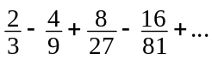
Working:
Answer:
......................................................................
(Total 4 marks)

43. The Acme insurance company sells two savings plans, Plan A and Plan B.
For Plan A, an investor starts with an initial deposit of $1000 and increases this by $80 each month, so that in the second month, the deposit is $1080, the next month it is $1160 and so on.
For Plan B, the investor again starts with $1000 and each month deposits 6% more than the previous month.
(a) Write down the amount of money invested under Plan B in the second and third months.
(2)
Give your answers to parts (b) and (c) correct to the nearest dollar.
(b) Find the amount of the 12th deposit for each Plan.
(4)
(c) Find the total amount of money invested during the first 12 months
(i) under Plan A;
(2)
(ii) under Plan B.
(2)
(Total 10 marks)

44. $1000 is invested at the beginning of each year for 10 years.
The rate of interest is fixed at 7.5% per annum. Interest is compounded annually.
Calculate, giving your answers to the nearest dollar
(a) how much the first $1000 is worth at the end of the ten years;
(b) the total value of the investments at the end of the ten years.
Working:
Answers:
(a) ..................................................................
(b) ..................................................................
(Total 4 marks)

45. Find the sum of the arithmetic series
17 + 27 + 37 +...+ 417.
Working:
Answer:
.........................................................................
(Total 4 marks)

46. An arithmetic series has five terms. The first term is 2 and the last term is 32. Find the sum of the series.
Working:
Answer:
......................................................................
(Total 4 marks)

